LEXINGTON Light Weight Cupboard

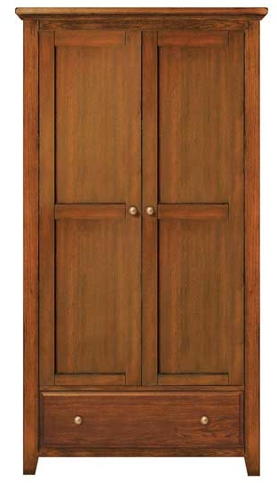

|  |
| --- |
| **DESCRIPTION** |
| LEXINGTON dream designing has introduced an extra long multi storage charcoal cupboard with extra space. The cupboard has a nice feel with smooth surface and the white color enables it to adjust to its surround. It will give your house a complete different look. Charcoal is a light durable and strong material it can be easily carried by two people and is build to hold heavy objects. |

|  |  |  |
| --- | --- | --- |
| **Price** | **650$** | |
| **Dimensions** | **H** x **W** x **L** | **75in x 22in x 31in** |
| **Features** | **The cupboard contains two doors and one huge chest perfect to support weight** | |
| **Finished** | **Smooth Brown paint** | |
| **Available in** | **Brown Only** | |